Graphics for December

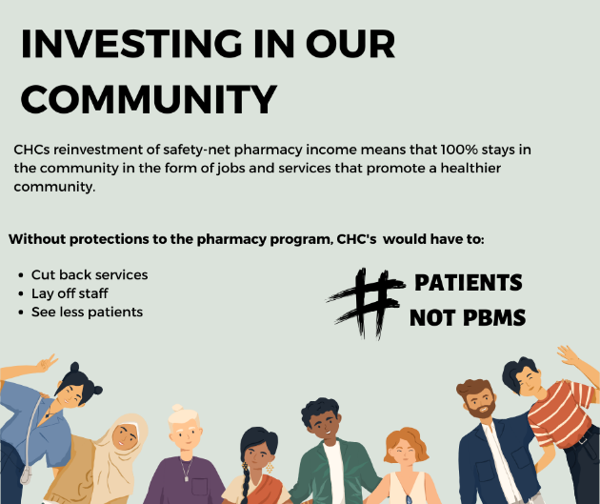

Hashtags
#patientsnotpbms
#valuechcs
#protect340b
#kychc
#rhcsfor340b
#kygeneralassembly2024

Twitter “X” Handles:
Kentucky Legislative Research Commission @ky_lrc
Bluegrass Politics @BGPolitics
KY House Republicans @KYHouseGOP
Kentucky Democrats @KyDems
KY Senate Majority @KYSenateGOP
KET Public Affairs @PubAffairsKET
KY House Democrats @kyhousedems
KY Senate Democrats @kysenatedems

